Iowa Exercise Oncology Clinic: Directions and Parking

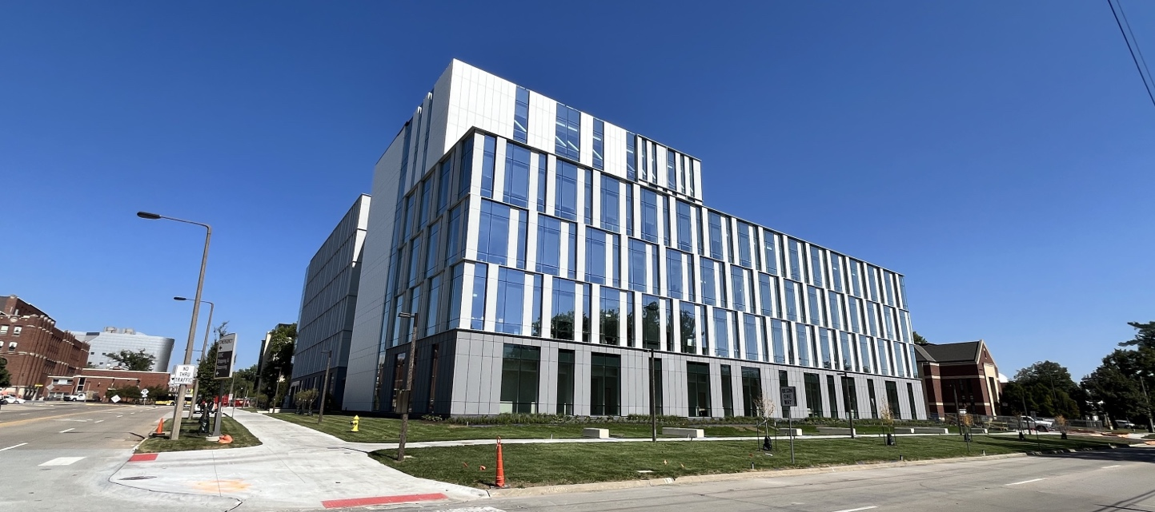
302 S. Grand Avenue, Iowa City, IA 52242

Welcome!
We are glad you will be visiting us at the Iowa Exercise Oncology Clinic.

Driving Directions

Directions from interstate 80:
- Take the 1st Ave. exit; EXIT 242.
- If coming from the East, turn left onto 1st Ave.
- If coming from the West, turn right onto 1st Ave.
- Turn left onto 2nd St./US-6 E.
- Turn right onto Hawkins Drive.
- Turn left onto Melrose Ave.
- Turn left onto S. Grand Ave.
- The Iowa Exercise Oncology Clinic, 302 S. Grand Avenue, will be on your right.

Directions from US-218:
- Take the Melrose Ave. exit, EXIT 93.
- If coming from the North, turn left onto Melrose Ave.
- If coming from the South, turn right onto Melrose Ave.
- Turn left onto S. Grand Ave.
- The Iowa Exercise Oncology Clinic, 302 S. Grand Avenue, will be on your right.

Parking Directions:
We ask that you park in Hospital Parking Ramp 4, which is located across Grand Avenue from the Iowa Exercise Oncology Clinic.

See the stars on the map below.
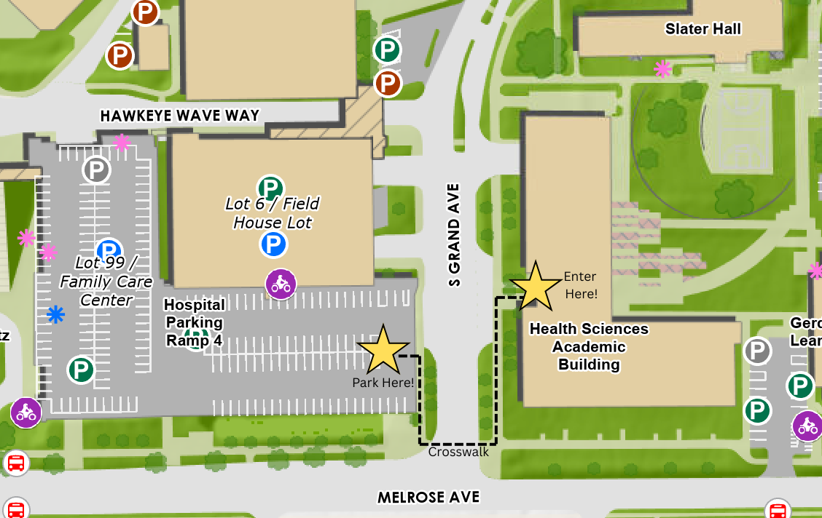

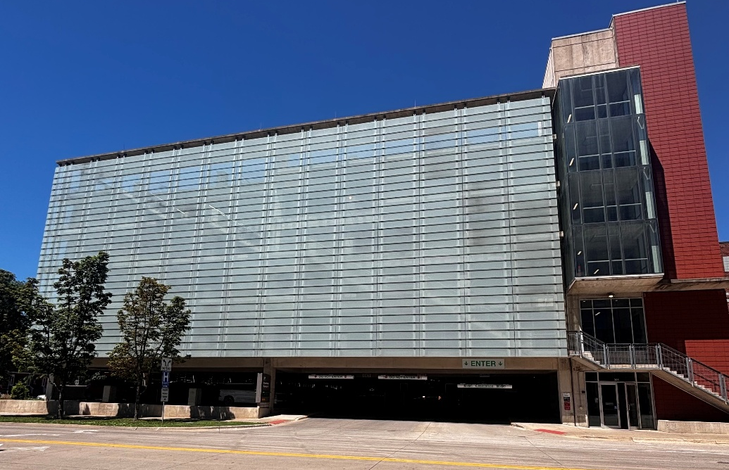
Parking Ramp 4.

Use the crosswalk at the intersection of Melrose Ave. and S. Grand Ave.
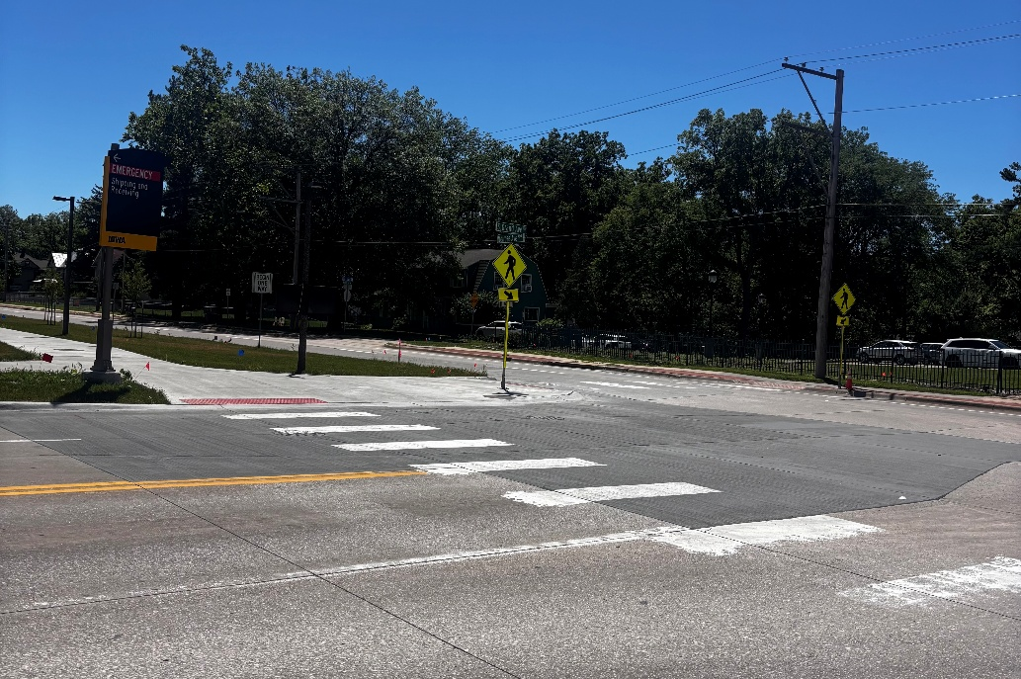
Melrose Ave. and S. Grand Ave. Intersection.

Parking Ramp Maps and Information:
https://transportation.uiowa.edu/parking/facilities/parking-ramp-4

Campus Accessibility Map:
https://maps.facilities.uiowa.edu/accessibility

